Garfield-Clarendon Model Railroad Club

Layout Control System

4501 N Clarendon Avenue

Chicago, IL 60640

LCS Controller Assembly Instructions

What you’ll need

To assemble a LCS Controller, have the following tools at your side.

1. LCS Controller printed circuit board
2. Soldering iron
3. Solder (Rosin Core)
4. Wire cutters
5. Small screw driver
6. LCS Parts kit

# Getting Started

Plug in your soldering iron and place the LCS Controller circuit board in front of you as pictured

[picture of blank board]

# Begin Assembly

To make assembly as simple as possible, start by placing the flattest items first followed by taller items in order of height.

1. Begin by soldering the 4 resistors in place. Resistors are labeled as 220 ohm (2) and 3.3 k ohm (2) on the printed circuit board. The orientation of the resistor is not important. [picture with resistors]
2. Place the voltage regulator in place as pictured. [picture with regulator]
3. Bend the voltage regulator backwards until the hole in the regulator’s heat sink aligns with the hole in the circuit board. The hole alignment does not have to be exact. [picture with regulator in place]
4. Solder the voltage regulator in place.
5. Place the pin headers onto the ESP 8266 module. The pin headers can be broken at any pin to create a header with the correct number of pins. Start by lining up the first pin of the header with the first hole in the ESP 8266. With your fingers, mark the last pin. Break the pin header at this point. Do this for both sides of the ESP 8266 module. The pins fit very tightly into the module so it takes a bit of force to properly insert the pins into the unit. It’s easier to place the unit on a flat surface with the pins facing down and firmly press on the center of the ESP9 8266 module until the pins slide into place. Adjusting pressure side-to-side may be necessary to get the pins properly seeded.
6. Very carefully, solder each pin to the ESP 8266. This is, by far, the most challenging soldering job. Be very careful not to let the solder cross over to the adjacent pins or the metal cover.
7. Place the ESP 8266 on the circuit board as pictured and solder into place. [picture with esp8266]
8. Solder the 8 5-pin headers and the 1 4-pin header in place. Like the header for the ESP 8266, these headers are also break-away. [picture with annotations]
9. Solder the 10uf capacitor in place. Align the capacitor with the negative lead (short lead marked with a silver line with a – sign) with the hole marked with a “-“. [picture with 10uf capacitor in place]
10. Solder the .1uf capacitor in place. Align the capacitor with the negative lead (short lead marked with a silver line with a – sign) with the hole marked with a “-“. [picture with .1uf capacitor in place]
11. Solder the red LED in place with the flat side/shorter lead aligned with the bottom hole.
12. Solder the power jack in place as pictured. Use a generous amount of solder on each of the three connections; making sure the solder completely covers the hole.

# Upload Firmware

The unit is now ready to be programmed! To upload the firmware, the LCS Controller needs to be connected to the club’s computer located in the overlook.

1. Plug the programming serial cable into a USB port on the computer and set the switch on the box to “upload”. [picture of the serial cable and box]
2. Connect the other end of the serial cable to the 5-pin header to the left of the ESP 8266 module on the printed circuit board with the blue wire side of the connector aligned with the bottom pin of the header as pictured [cable attached to board with annotation of blue wire]
3. Connect the power supply (from the LCS parts kit) to the LCS Controller. The red LED should light on the controller.
4. Launch the Arduino IDE program by double-clicking the icon on the computer’s desktop [screenshot of desktop]
5. Load the LCSController project. Go to File->Open and browse to the Document->Arduino->LCSController directory. Select the LCSController.ino file:

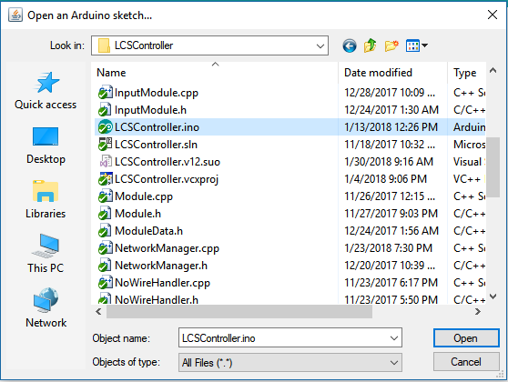

1. Double check the settings by selecting the Tools menu item. Verify the settings look like this:

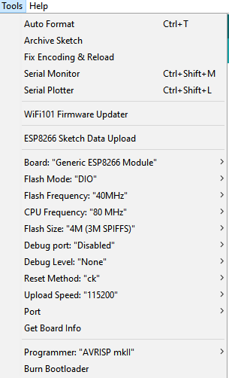

The important settings are:

* Board: “Generic ESP8266 Module”
* Flash Mode: “DIO”
* Flash Frequency: “40MHz”
* CPU Frequency: “80 MHz”
* Flash Size: “4M (3M SPIFFS)”
* Upload Speed: “115200”

1. Upload the firmware by selecting Sketch->Upload. The Arduino IDE program will compile the LCS Controller firmware and then begin the process of uploading the firmware to the controller. You’ll know the process is working when you see the blue LED on the LCS Controller flashing.
2. After the blue LED stops flashing and the Arduino program indicates the firmware uploaded successfully, unplug the controller.
3. Set the switch on the USB serial cable box to “serial”.???????
4. From the Arduino IDE program, select Tools->Serial Monitor
5. Change the baud rate to 38400 using the drop-down box in the lower right corner. The serial monitor window should look like this: [screen shot of serial monitor]
6. Plug in the LCS Controller.
7. Make note of the serial number printed out in the serial monitor. The LCS Controller will “boot-up” and print out some information about the firmware version number and the controller’s serial number (among other things). Write the serial number on a piece of masking tape and place it on the bottom of the LCS Controller board.
8. Un-plug the unit.